Jordan, McClain, Jason, Jeremy

GEOG 4043

November 4th, 2021

**Socioeconomic Effects of COVID-19 RTD Bus Stop Changes**

**Introduction**

We propose to create an interactive geovisualization that uses6 month sums of RTD bus stop frequencies before and during the COVID-19 pandemic within the Denver Metro Area. We will include a linked parallel coordinate plot visualization that relates the bus stop frequencies to census tract level socioeconomic data (e.g. job density, average education level, median household income, etc.). Our dataset will include three interactive maps that classify bus stop frequency by census tract. This will potentially allow the user to explore socioeconomic patterns associated with changes in bus frequency before and during the pandemic.

Our plan is to tie bus frequency to the aforementioned socioeconomic factors and allow the user to make conclusions about how changing bus stop frequencies could potentially affect census tracts by linking the map to our parallel coordinate plot This tool will enable the user to easily visualize the effects of the pandemic and public transportation via spatiotemporal elements.

This visualization allows the user to query different years, census tracts, and different variables associated with public transportation (routes) and socioeconomic factors. We will be using a three-panel layout, which will have the main map on the top left, the query tool on the top right, and within the bottom center there will be a parallel coordinate plot that allows the user to query bus stop frequency and the above socioeconomic factors associated with the respective census tract. Our visualization technique for the data is to be determined, but the numerous articles below describe different methods for visualizing public transportation data.

**Data Sources, Structure, and Specifications**

Our data has an open use policy as well. All data is open access provided by local, state, or federal government or third parties in support of those objectives. RTD data was sent to our group by RTD directly and shared openly on their GIS portal.

Our group will also use census-tract data acquired by CU Boulder Graduate Student: Katie Tyler.

The Appendix includes links to data sources, toolkits, plugins, and demo websites using various tools that can provide our group with a guiding idea on how to best display this data in a meaningful way as well as practically.

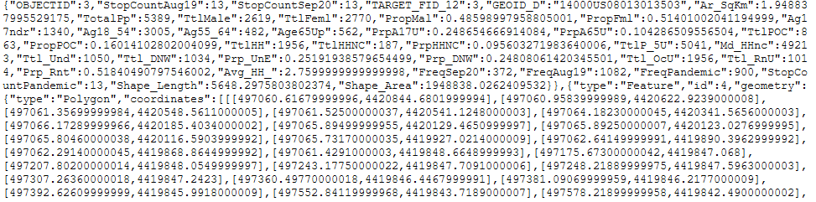GeoJSON

* **GeoJSON Breakdown:**

Within this GeoJSON object, we have the following: the number of stops (StopCount_DATE), the amount of times a bus has stopped at each of these stops (Freq_DATE),median household income, job density, percentage of unemployment, percent people of color, the average education level, average household size and general population statistics (e.g. total population, proportion of male and female). This is followed by the polygon of each census tract respectively.

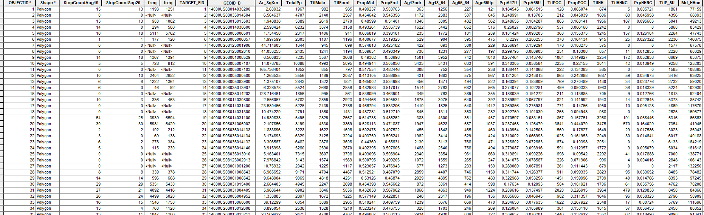

**External Tools and Plugins**

* D3.js
  + D3 Parallel Coordinates
  + Small multiples
  + DOM (javascript)
* JQuery Libraries
* Leaflet.js
  + Grid Layer
  + GeoJSON
  + Icon
  + TileLayer
  + Modifying and getting map states
  + Panes
  + Vector Layers (path, polyline, polygon)
  + Mapbox Tiles
* Mapbox API
* ArcMap
* R Studio

**Implementation Timeline**

| ***Date*** | ***Task*** |
| --- | --- |
| **2 NOV 21** | * Revision to proposal complete * Initial skeleton completed, data, visuals, timeline, lit review complete. * Data acquisition and cleaning * Plug-in research |
| **3/4 NOV 21** | * Grammar, content, grammar/content review * Revised proposal complete - submitted * Mockup near compete * Define variables desired to be displayed on map * Choosing type of display final, final touch-ups * What Displays are we choosing, what plugins etc |
| **6/7 NOV 21** | * Have data processed ready for insertion into web code * The final decision on data presentation * R-code / Arc Processing complete (bus data complete) * Point to polygon complete, R-Code tidied up * Mockup Complete / Transfer to code * Testing visual systems, the final decision on display setup * Run demo code, debug * Things like what Displays are we choosing, what plugins etc * Final Plugins selected and final |
| **9/11 NOV 21** | * November have Mockup turned to initial code * Group review of code complete * Alpha Review * Code should have final  presentation quality to it prepped for feedback * Practice I (presentation & demo) |
| **13/14 NOV 21** | * Nov prep code/alpha for class display * Any changes that come up in testing refine visuals, prep for the presentation (lightning 2) * Practice II (presentation & demo) |
| **16 NOV 21** | * Have code ready for alpha display to the class |
| **23/25 NOV 21** | * Nov have beta code complete * Taking feedback |
| **27/28 NOV 21** | * Initial presentation Script * Initial Video Script * Practice I and II |
| **30 NOV 21** | * Final touches/review * Polish presentation script * Polish video Script * Practice III |
| **2/3 DEC 21** | * Generate Final video * Review presentation touch up * Last Practice / Video created * Final Video made * Final Presentation made |
| **4 DEC 21** | * (this is the final sanity check a day, after all, it is complete) * Review video - submit the video * Review Presentation - submit the presentation * Submit final code |

**MOCKUP (REVISED)**

**Classified census tracts with bus stop frequency**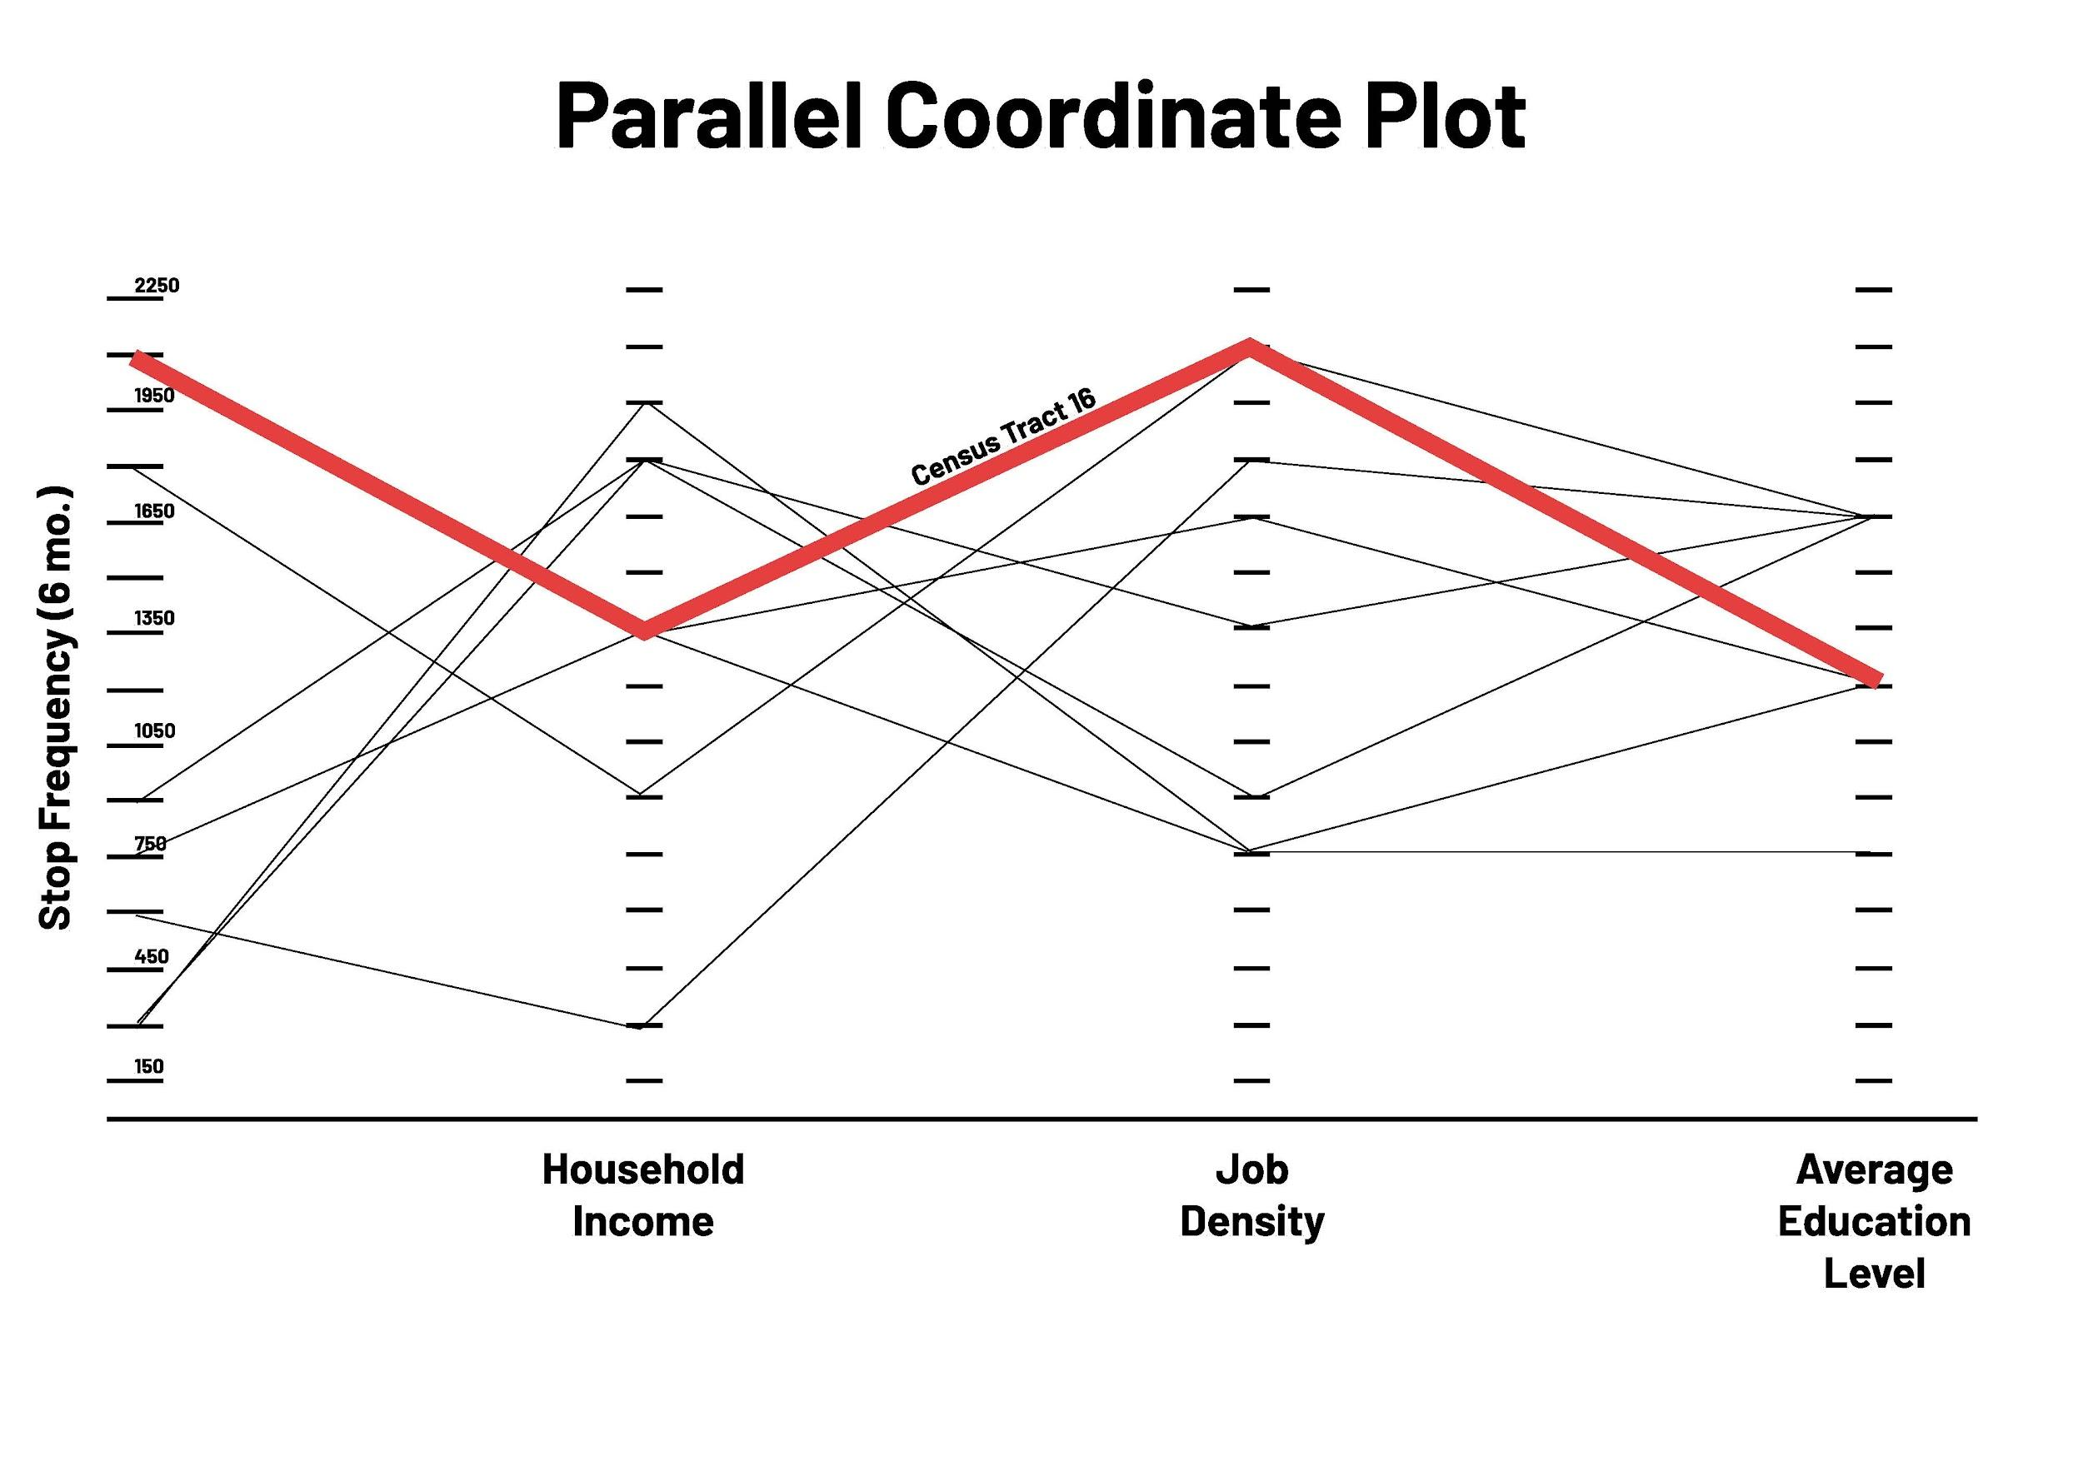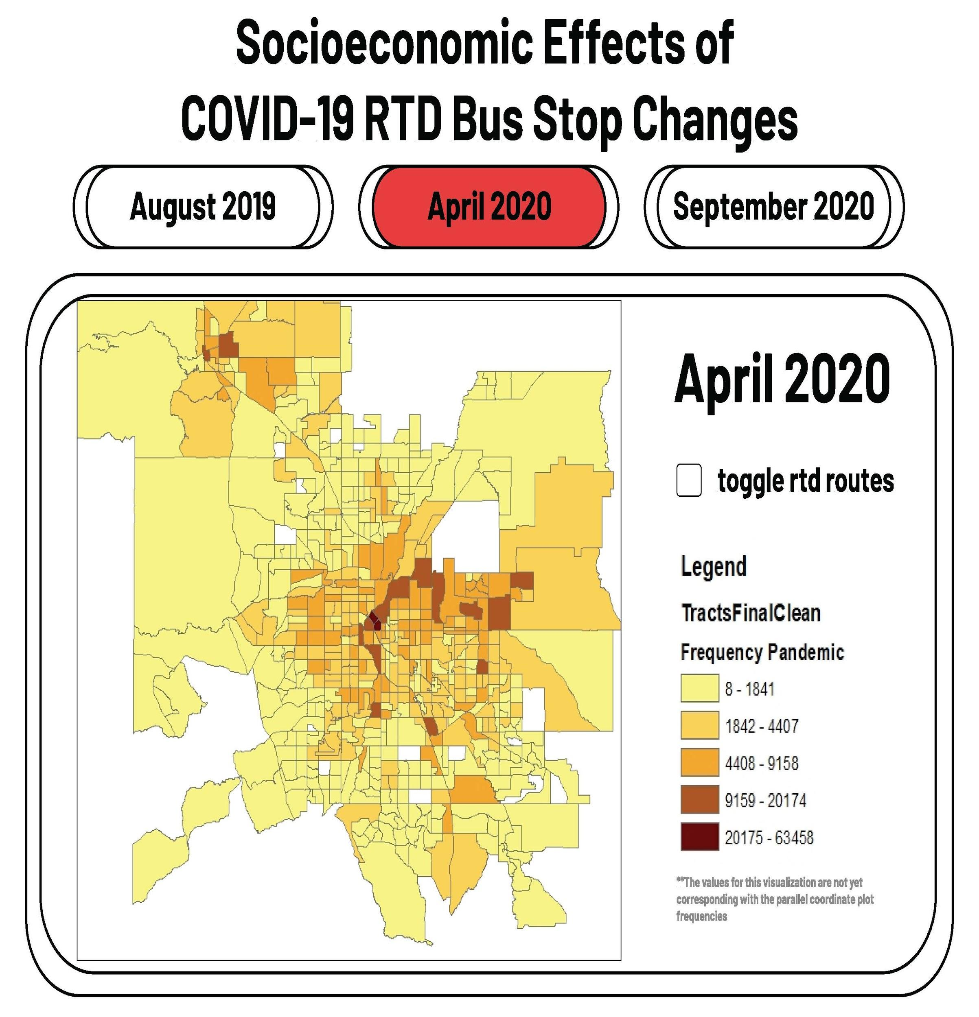

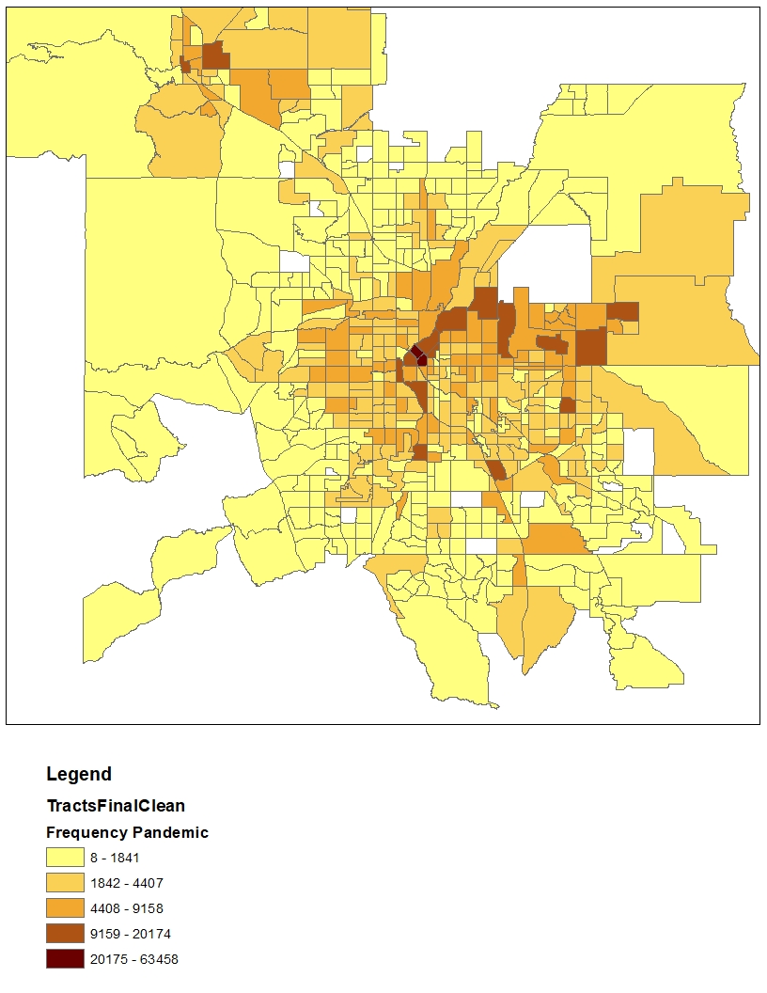

**Design mockups (HISTORICAL)**

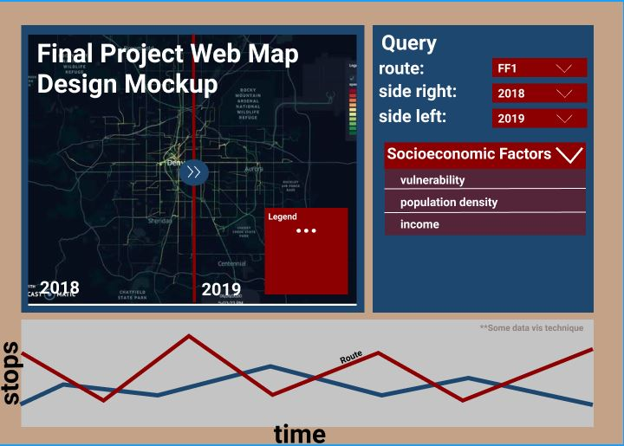

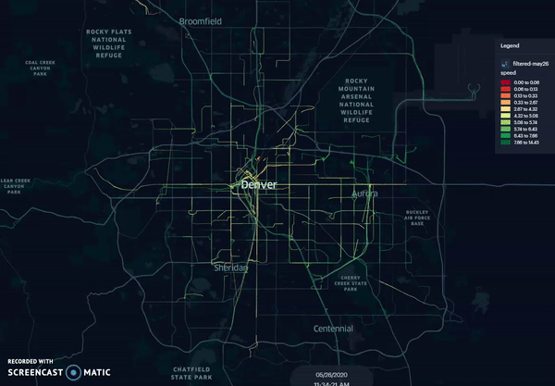

Kurkcu, A. (2021, June 17). *Visualizing Bus Trajectories in Denver*. Medium.<https://towardsdatascience.com/visualizing-bus-trajectories-in-denver-85ff02f3a746>

**REVISED BIBLIOGRAPHY & LITERATURE REVIEW**

* Pang, J., Tian, C., Huang, Y., Buckles, B., & Mirzaei, A. (2017). Atvis: A New Transit Visualization System. In D. A. Griffith, Y. Chun, & D. J. Dean (Eds.), *Advances in Geocomputation* (pp. 85–96). Springer International Publishing.<https://doi.org/10.1007/978-3-319-22786-3_9>
  + This paper discusses a specific system used to more efficiently visualize spatial and temporal transit data. This system compares traditional mapping and presentation tools to “Atvis”. Atvis focuses more on ridership, visualizing traffic data at or between stops, and inter-stop relationships, disregarding information that may not be essential to a user. The tool may not specifically apply to our web map, however it would provide possible insight into how a similar web map could be generated and displayed. The system focuses on similar datasets as the web map being made.
* Robert M Edsall, *The parallel coordinate plot in action: design and use for geographic visualization*, Computational Statistics & Data Analysis, Volume 43, Issue 4, 2003, Pages 605-619, ISSN 0167-9473, <https://doi.org/10.1016/S0167-9473(02)00295-5>.
  + This article discusses using parallel coordinate plots to represent spatial-temporal data and linking it to maps and or scatterplots. Using parallel coordinate plots allows for the analysis of phenomenon through feature identification, pattern recognition, and ultimately knowledge construction. This allows for the identification of problems. Parallel coordinates plots accomplish this by combining multiple data analysis techniques such as linking, brushing, and focusing. Using this tool is most helpful when looking at large multivariate data sets to show relationships.
* Natalia Andrienko, Gennady Andrienko, Peter Gatalsky*, (2002) Exploratory Spatio-temporal visualizations: An analytical review—ScienceDirect*. (n.d.). <https://www.sciencedirect.com/science/article/pii/S1045926X03000466>
  + Many current software tools for visualizations of Spatio-temporal data, on the one hand, make use of various opportunities provided by modern computer technologies. However, these systems incorporate the legacy from the conventional cartography. Leading to two different questions (1) what types of Spatio-temporal data they apply to; (2) what exploratory tasks they can potentially support. The result of the study is potentially helpful for data analysts—identifying users of geovisualization tools and providing current guidelines for selecting proper exploratory techniques depending on the characteristics of data to analyse and the goals of the analysis. This enables suggested typology of tasks that could be helpful in tool designers and developers of various domain-specific geovisualization applications.
* Prommaharaj, P., Phithakkitnukoon, S., Demissie, M. G., Kattan, L., & Ratti, C. (2020). Visualizing public transit system operation with GTFS data: A case study of Calgary, Canada. *Heliyon*, *6*(4), e03729.<https://doi.org/10.1016/j.heliyon.2020.e03729>
  + This paper discusses the General Transit Feed Specification (GTFS). Outlining this dataset that agencies generate and share openly with the public.theirese GTFS fein data for scheduled transit service including stop and route locations and schedules information. This paper discusses how to demonstrate the potential of GTFS data, specifically, specifically describing GTFS data visualization tools that display both spatial and temporal data from transit services allowing user insights can be had. Our web map project uses GTFS data collected from Denver RTD, and may provide some insight into how tools can be made/used to generate interactive displays.
* Andrienko, Andrienko, and Gatalsky, *Exploratory spatio-temporal visualization: an analytical review*, Journal of Visual Languages & Computing, Volume 14, Issue 6, December 2003, Pages 503-541, [doi:10.1016/S1045-926X(03)00046-6](https://www.researchgate.net/publication/222544758_Exploratory_Spatio-Temporal_Visualization_An_Analytical_Review)
  + The topic of this article is on the tools and techniques used for the exploration of spatio-temporal visualization. They look at what tools can be used based on the type of spatio-temporal data and then what type of query they can support. They accomplish this by dividing the data into three components, when, what and where. For example we can describe characteristics of this object (location) at the given time moment. They go on to discuss exploratory techniques and data characteristics, and exploratory techniques and data analysis tasks. We can implement this when, what, where technique to our data as we begin to process.

***INITIAL BIBLIOGRAPHY (OLD For historical Reference)***

* Pang, J., Tian, C., Huang, Y., Buckles, B., & Mirzaei, A. (2017). Atvis: A New Transit Visualization System. In D. A. Griffith, Y. Chun, & D. J. Dean (Eds.), *Advances in Geocomputation* (pp. 85–96). Springer International Publishing.<https://doi.org/10.1007/978-3-319-22786-3_9>
  + This paper discusses a specific system used to more efficiently visualize spatial and temporal transit data. This system compares traditional mapping and presentation tools to “Atvis”. Atvis focuses more on ridership, visualizing traffic data at or between stops, and inter-stop relationships, disregarding information that may not be essential to a user. The tool may not specifically apply to our web map, however it would provide possible insight into how a similar web map could be generated and displayed. The system focuses on similar datasets as the web map being made.
* Prommaharaj, P., Phithakkitnukoon, S., Demissie, M. G., Kattan, L., & Ratti, C. (2020). visualizing public transit system operation with GTFS data: A case study of Calgary, Canada. *Heliyon*, *6*(4), e03729.<https://doi.org/10.1016/j.heliyon.2020.e03729>
  + This paper discusses the General Transit Feed Specification (GTFS). Outlining this dataset that agencies generate and share openly with the public. These GTFS feeds contain data for scheduled transit service, including stop and route locations and schedules information. This paper discusses how to demonstrate the potential of GTFS data, specifically, explicitly describing GTFS data visualizations tools that display both spatial and temporal data from transit services allowing user iinsights. Our web map project uses GTFS data collected from Denver RTD and may provide insight into how tools can be made/used to generate interactive displays.
* Stewart, C., Diab, E., Bertini, R., & El-Geneidy, A. (2016). Perspectives on Transit: Potential Benefits of Visualizing Transit Data. Transportation Research Record, 2544(1), 90–101. https://doi.org/10.3141/2544-11
  + This paper touches on various advancements in information and communication technologies that have enabled transit agencies to create highly accurate streams of data on a frequent and timely basis. These agencies are invested in targeting new methods of visualizing data to communicate the results of their planning efforts, operational investments, and overall transit performance to decision-makers and the public (or private stakeholders if non-public owned. Most agencies provide numerous data, including Google’s general transit feed specification schedule data, automatic vehicle location data, and automatic passenger count data. This paper aims to demonstrate the potential of these data sources; specifically, the report uses transit data from Montreal, Quebec, Canada, that are of interest. Some of these measures can also help in communicating the positive attributes of public transportation to the community. Performance measures are generated at different scales, including transit system, neighbourhood, route, and stop levels. This paper expands on previous research on transit performance research and visualizations by adopting currently available resources for so-called big data.

**DATA SOURCES / PLUG-INS / DEMO SYSTEMS**

* Specify the (JavaScript) libraries (plugins, for example, Leaflet for map, link <http://leafletjs.com/>
  + [(Links to an external site.)](http://leafletjs.com/)
* D3 for ***Parallel Coordinates,*** link
  + - h[ttp://mbostock.github.io/d3/talk/20111116/iris-parallel.html](http://mbostock.github.io/d3/talk/20111116/iris-parallel.html)

| **DATA SOURCES** | <https://www.nhgis.org/>  <https://gis-rtd-denver.opendata.arcgis.com/>  <https://transitfeeds.com/>  Direct Contact to RTD data share office |
| --- | --- |
| **PLUG-INS / Libraries** | <https://www.d3-graph-gallery.com/parallel>  <https://bl.ocks.org/jasondavies/1341281>  <https://docs.mapbox.com/mapbox-gl-js/plugins/>  *jQuery libraries -*  <http://leafletjs.com/>  <https://github.com/Leaflet/Leaflet>  <https://colorlib.com/wp/jquery-map-plugins/>  <https://www.jqueryscript.net/tags.php?/map/>  <https://www.arcgis.com/home/item.html?id=040da6b55503489b90fa51eea6483932>  D3.js  D3 Parallel Coordinates  Small multiples  DOM (javascript)  JQuery Libraries  Leaflet.js  Grid Layer  GeoJSON  Icon  TileLayer  Modifying and getting map states  Panes  Vector Layers (path, polyline, polygon)  Mapbox Tiles  Mapbox API  ArcMap  R Studio |
| **DEMO IDEAS** | [*Visualizing Transit Ridership in Remix: Our Design Process | Remix Blog*](https://www.remix.com/blog/visualizing-transit-ridership-in-remix-our-design-process)  [*https://kepler.gl/demo*](https://kepler.gl/demo)  <https://studio.unfolded.ai/home>  <https://towardsdatascience.com/visualizing-bus-trajectories-in-denver-85ff02f3a746>  <https://www.data-to-viz.com/graph/parallel.html>  <https://syntagmatic.github.io/parallel-coordinates/>  [Visualizing Better Transportation: Data & Tools | by Steve Pepple | Medium](https://medium.com/@stevepepple/visualizing-better-transportation-data-tools-e48b8317a21c)  [Visualize Your Map Data with Basic Viz Packages | by Jen Wadkins | Towards Data Science](https://towardsdatascience.com/visualize-your-map-data-with-basic-viz-packages-448ef703ffc2)  <https://www.mapzen.com/blog/animating-transitland/>  <https://www.mapzen.com/projects/>  <https://www.esri.com/arcgis-blog/products/arcgis-online/analytics/who-does-my-public-transit-system-serve/?rmedium=redirect&rsource=blogs.esri.com/esri/arcgis/2016/06/20/who-does-my-public-transit-system-serve>  <https://www.esri.com/arcgis-blog/products/network-analyst/transportation/map-the-frequency-of-transit-service-across-your-city-and-find-out-why-it-matters/> |